INDEX

|  |  |  |  |
| --- | --- | --- | --- |
| S.NO. | TOPIC | DATE | SIGN |
|  |  |  |  |
|  |  |  |  |
|  |  |  |  |
|  |  |  |  |
|  |  |  |  |
|  |  |  |  |
|  |  |  |  |
|  |  |  |  |
|  |  |  |  |
|  |  |  |  |
|  |  |  |  |
|  |  |  |  |
|  |  |  |  |

Oops LAB

FILE

NAME -

ROLL NO. -

PROGRAM NO.-1

**AIM** – Define a class right angled triangle and determine its area and perimeter though separate

interfaces.

SOURCE CODE

#include<iostream>

#include<math.h>

using namespace std;

class righttriangle

{

float height,base;

public:

void getvalue()

{

cout<<"\nENTER THE HEIGHT OF THE TRIANGLE :";

cin>>height;

cout<<"\nENTER THE BASE OF THE TRIANGLE :";

cin>>base;

}

float perimeter();

float area();

};

float righttriangle::perimeter()

{

float a= height+base+sqrt((height*height)+(base*base));

return a;

}

float righttriangle::area()

{

float a= base*height/2;

return a;

}

int main()

{

righttriangle one;

one.getvalue();

cout<<"\nPERIMETER OF TRIANGLE :"<<one.perimeter();

cout<<"\n\nAREA OF TRIANGLE :"<<one.area();

getch();

return 0;

}

OUTPUT

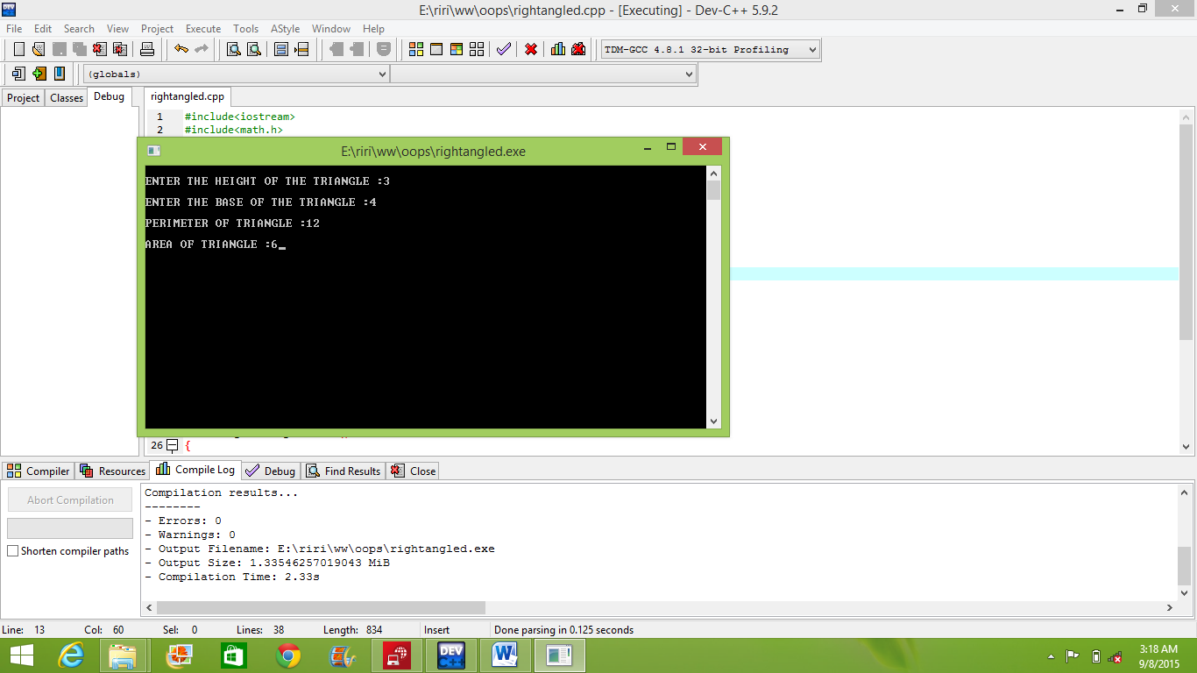

PROGRAM NO.-2

**AIM** – Define a class complex number that has behavior Add and Subtract .Output the sum and

difference of these object by creating two object in main program.

SOURCE CODE

#include<iostream>

using namespace std;

class complex

{

float real,img;

public:

void insert(float a,float b)

{ real=a; img=b;}

void display()

{ cout<<real<<" +i "<<img; }

complex Add(complex);

complex Subtract(complex);

};

complex complex::Add(complex a)

{ complex c;

c.real=a.real+real;

c.img=a.img+img;

return c;

}

complex complex::Subtract(complex b)

{ complex c;

c.real=real-b.real;

c.img=img-b.img;

return c;

}

int main()

{

complex one,two,fin;

float r,i;

cout<<"\nENTER THE TWO NUMBERS OF FIRST COMPLEX NUMBER:";

cin>>r>>i;

one.insert(r,i);

cout<<"\nENTER THE TWO NUMBERS OF SECOND COMPLEX NUMBER:";

cin>>r>>i;

two.insert(r,i);

fin=one.Add(two);

cout<<"\nADDITION COMPLEX A AND B:";

fin.display();

fin=one.Subtract(two);

cout<<"\nSUBTRACTION COMPLEX A AND B:";

fin.display();

return 0;

}

OUTPUT

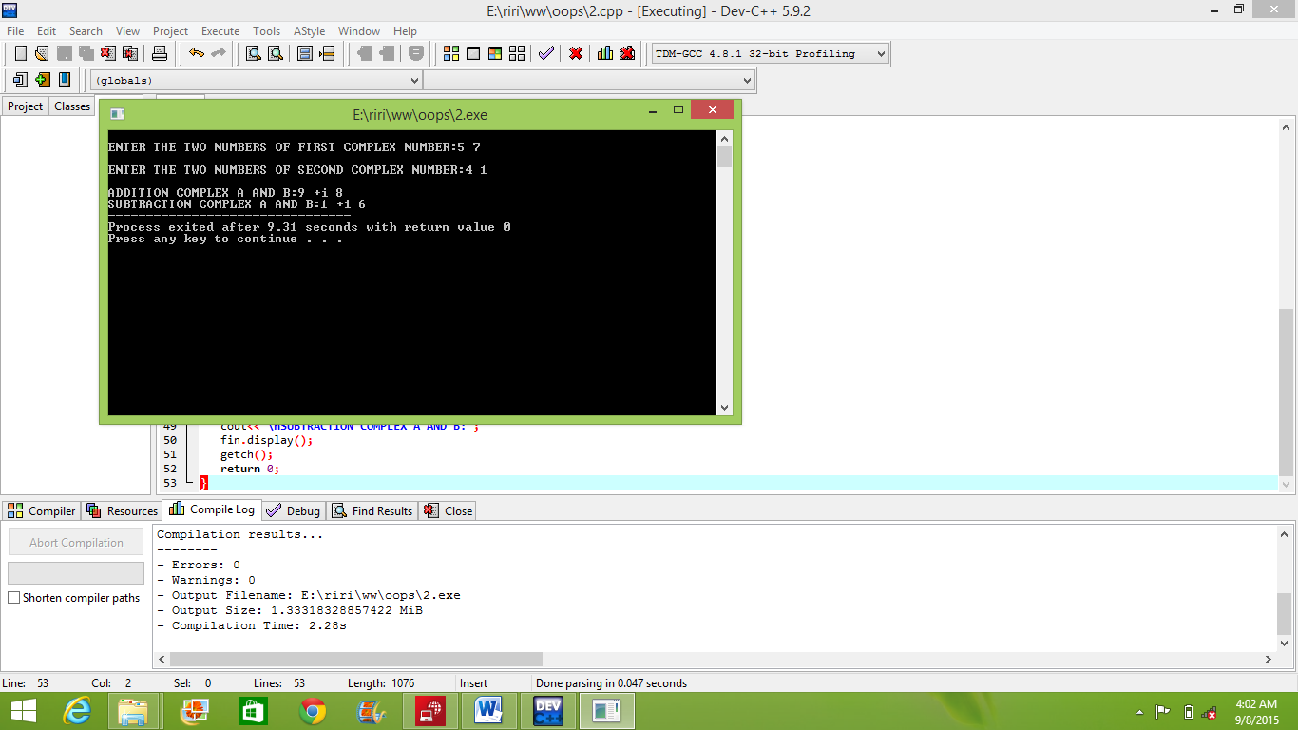

PROGRAM NO.-3

**AIM** – Write a program to define a class Income having interfaces Pay salary, Compute deduction

, Calculate Tax according to their salary consisting of Basic, DA, HRA.

SOURCE CODE

#include<iostream>

#include<math.h>

using namespace std;

class income{

float basic,da,hra;

float salary;

public:

float paysalry(float a,float b,float c)

{

basic=a;

da=b;

hra=c;

salary=basic+da+(hra*0.15);

return salary;

}

float deduction()

{

return 0.08*basic;

}

float tax()

{

float tax;

if(salary<100000)

{ tax=salary*0.2; }

else

if(salary>=100000)

{ tax=0.3*salary;

tax=1.1*tax;

}

return tax;

}

};

int main()

{

income a;

float basic,hra,da;

cout<<"\n ENTER THE BASIC,HRA ,DA :";

cin>>basic>>hra>>da;

cout<<"\n SALARY :"<< a.paysalry(basic,hra,da);

cout<<"\n Deduction :"<< a.deduction();

cout<<"\n TAXES :"<< a.tax();

return 0;

}

OUTPUT

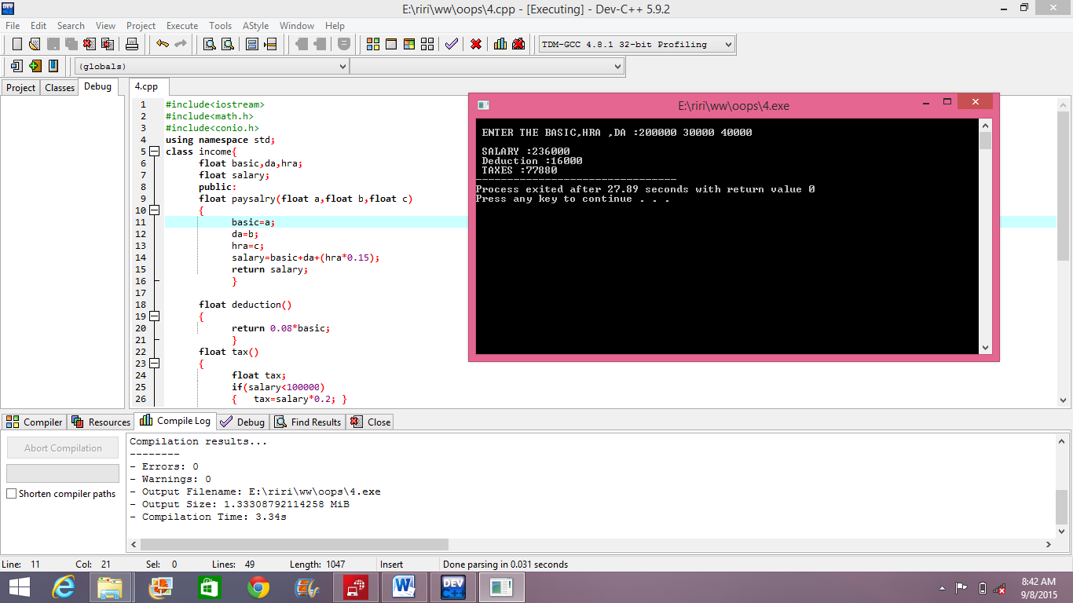

PROGRAM NO.-4

**AIM** – Write a C++ class Employee and initialize all its data members no. dob ,rank and salary and

implement increase rank and increase salary function.

SOURCE CODE

#include<iostream>

#include<conio.h>

using namespace std;

class employee{

int number;

char c[15];

int rank;

float salary;

public:

employee()

{

number=0;

c[0]='\0';

rank=0;

salary=0.0;

}

void getdata()

{

cout<<"\nENTER THE NUMBER OF EMPLOYEE :";

cin>>number;

cout<<"ENTER THE date of birth OF EMPLOYEE :";

cin>>c;

cout<<"ENTER THE RANK OF EMPLOYEE :";

cin>>rank;

cout<<"ENTER THE Salary OF EMPLOYEE :";

cin>>salary;

}

int getno()

{

return number;

}

void raise()

{

salary=1.1*salary;

}

void increaserank()

{

rank=rank+1;

salary=1.25*salary;

}

void display()

{

cout<<"\nNUMBER OF EMPLOYEE :"<<number;

cout<<"\ndate of birth OF EMPLOYEE :"<<c;

cout<<"\nRANK OF EMPLOYEE :"<<rank;

cout<<"\nSalary OF EMPLOYEE :"<<salary;

}

};

int main()

{

employee e[10];

int n,t;

cout<<"\nENTER THE NO. OF EMPLOYEE YOU WANT TO ENTER :";

cin>>n;

cout<<"\nENTER EMPLOYEE DETAILS \n";

for(int i=0; i<n;i++)

{

cout<<"\n EMPLOYEES :"<<i+1;

e[i].getdata();

}

cout<<"\nENTER THE EMPLOYEE NUMBER YOU WANT RAISE SALARY :";

cin>>t;

for(int i=0; i<n; i++)

{

if(e[i].getno()==t)

{ e[i].raise(); }

}

cout<<"\nENTER THE EMPLOYEE NUMBER YOU WANT RAISE RANK :";

cin>>t;

for(int i=0; i<n; i++)

{

if(e[i].getno()==t)

{ e[i].increaserank(); }

}

cout<<"\n\nEMPLOYEES DETAILS\n";

for(int i=0; i<n;i++)

{ cout<<"\n EMPLOYEES :"<<i+1;

e[i].display();

}

return 0;

}

OUTPUT

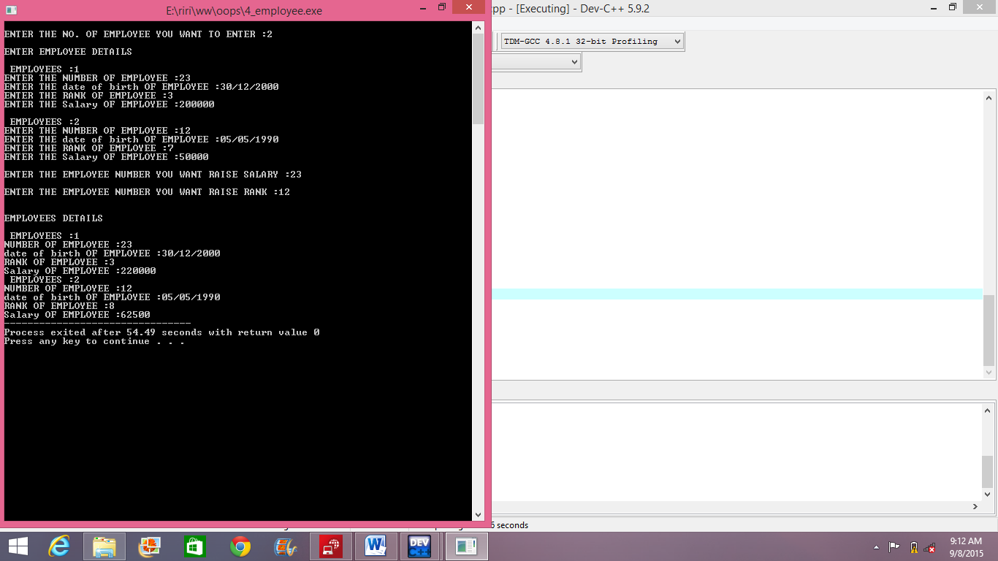

PROGRAM NO.-5

**AIM** – Write a C++ class for student having attributes rollno. ,department ,year and semester of study.

Students can be promoted by changing department.

SOURCE CODE

#include<iostream>

#include<string.h>

using namespace std;

class registers{

int rollno;

char department[100];

int semester;

int year;

public:

registers()

{

rollno=0;

strcpy(department," ");

year=0;

semester=0;

}

void registration(int roll,char *dep,int yr,int sem)

{

rollno=roll;

strcpy(department,dep);

year=yr;

semester=sem;

}

void display()

{

cout<<"\n ROLL NO :"<<rollno;

cout<<"\n DEPARTMENT :"<<department;

cout<<"\n YEAR :"<<year;

cout<<"\n SEMESTER :"<<semester;

}

void changedepartment(char *dep)

{

strcpy(department,dep);

}

int getrollno()

{

return rollno;

}

}s[50];

int main()

{

int rollno;

char department[100];

int semester,n;

int year;

cout<<"\nHOW MANY STUDENT INFO YOU WANT TO ENTER ";

cin>>n;

for(int i=0; i<n; i++)

{

cout<<"\n\n STUDENT :"<<i+1<<"\n";

cout<<"\n ROLL NO :";

cin>>rollno;

cout<<" DEPARTMENT :";

cin>>department;

cout<<" YEAR :";

cin>>year;

cout<<" SEMESTER :";

cin>>semester;

s[i].registration(rollno,department,year,semester);

}

cout<<"\n\n ENTER THR STUDENT ROLLNO YOU WANT TO CHANGE AND DEPARTMENT NAME:";

cin>>rollno;

cin>>department;

for(int i=0; i<n; i++)

{

if(s[i].getrollno()==rollno)

{

s[i].changedepartment(department);

}

}

cout<<"\n STUDENT INFO \n\n ";

for(int i=0; i<n; i++)

{

cout<<"\n\n STUDENT :"<<i+1<<"\n";

s[i].display();

}

return 0;

}

OUTPUT

